Mechatronics and Industrial Internet of Things

INDUSTRIAL DIESEL GENERATOR MONITORING AND PREVENTIVE MAINTENANCE SYSTEM

PROJECT REPORT

BHAVESH PRAKASH G - 24MER005
VASANTHAN B – 24MER060
PRABHUKUMAR N – 24MER40
AJAY PRABHAV A – 24MER003
SANTHAKUMAR M – 24MEL065
DEEPAK C – 24MEL069
- Project Overview:
Diesel generators are widely used as backup and continuous power sources in industries. Conventional monitoring often depends on manual inspection at fixed intervals, which can allow abnormal operating conditions to remain unnoticed until a failure occurs. The Industrial Diesel Generator Monitoring and Preventive Maintenance System is an IoT-based automated monitoring system designed to continuously observe the operating condition of a diesel generator. The system uses an ESP32 microcontroller as the main controller, together with a voltage sensor, ACS712 current sensor, and DHT11 temperature and humidity sensor to acquire important operating parameters in real time. The measured parameters are displayed locally through the Serial Monitor and transmitted to the ThingSpeak IoT cloud platform over Wi-Fi. A buzzer provides an immediate local warning whenever an abnormal condition such as high temperature, over-current, or abnormal voltage is detected. The main objective is to move generator maintenance from a purely time-based approach toward continuous condition-based monitoring and early fault detection.

- Project Statement:
Diesel generators are widely used as backup and continuous power sources in industrial environments. Conventional monitoring mainly depends on manual inspection and periodic maintenance, which may not identify abnormal operating conditions at the right time. Excessive temperature, over-current, voltage fluctuations, and unexpected generator failures can result in equipment damage, increased maintenance costs, and unplanned downtime. Therefore, an automated IoT-based monitoring system is required to continuously observe the generator condition, provide early warnings, and support preventive maintenance.
Therefore, there is a need for a wireless environmental monitoring system that can:
- Continuously monitor generator voltage, current, temperature, and humidity.
- Detect abnormal operating conditions using predefined threshold values.
- Provide an immediate audible warning through a buzzer.
- Display real-time sensor readings through the Serial Monitor.
- Transmit generator parameters to the ThingSpeak IoT cloud using Wi-Fi.
- Enable remote monitoring and historical data analysis.
- Support early fault detection and condition-based preventive maintenance.

- Proposed Solution:
The proposed system is an IoT-based diesel generator monitoring system designed to continuously monitor the generator’s operating condition. A voltage sensor measures the generator output voltage, an ACS712 sensor measures the load current, and a DHT11 sensor measures temperature and humidity. The ESP32 receives and processes all sensor readings, compares them with predefined threshold values, and identifies whether the generator is operating normally or abnormally. When an abnormal condition is detected, the buzzer is activated to alert the operator. Simultaneously, the ESP32 sends the monitored parameters through Wi-Fi to ThingSpeak for voltage sensor measures the generator output voltage.
- ACS712 sensor measures the current drawn by the connected load.
- DHT11 sensor measures temperature and relative humidity.
- ESP32 processes and evaluates all sensor readings.
- Threshold comparison identifies normal and abnormal conditions.
- Buzzer provides an immediate local warning during abnormal conditions.
- Serial Monitor displays the measured parameters in real time.
- ESP32 transmits sensor data to ThingSpeak through Wi-Fi.
- ThingSpeak provides remote monitoring and historical data visualization.
- Continuous monitoring supports early fault detection and preventive maintenance.
- System Architecture:
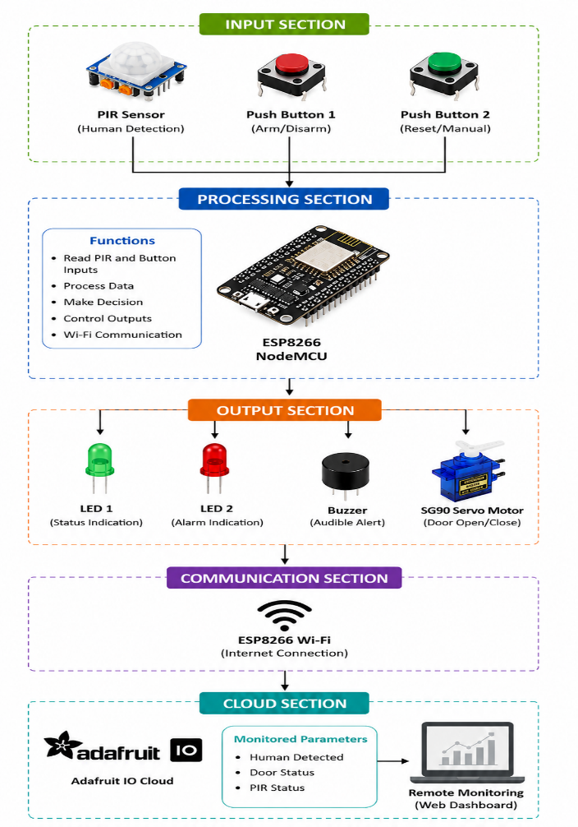

- Circuit Table:

Component | Pin / Connection | ESP32 Pin | Function
Voltage Sensor Module | OUT | GPIO 34 | Measures scaled generator voltage
Voltage Sensor Module | VCC | 3V3 | Sensor supply
Voltage Sensor Module | GND | GND | Common ground
ACS712 Current Sensor | OUT | GPIO 35 | Measures load current
ACS712 Current Sensor | VCC | 5V | Sensor supply
ACS712 Current Sensor | GND | GND | Common ground
DHT11 Sensor | DATA | GPIO 4 | Temperature and humidity data
DHT11 Sensor | VCC | 3V3 | Sensor supply
DHT11 Sensor | GND | GND | Common ground
Buzzer | SIG (+) | GPIO 25 | Audible abnormal-condition alert
Buzzer | GND (–) | GND | Common ground

- Circuit Design:
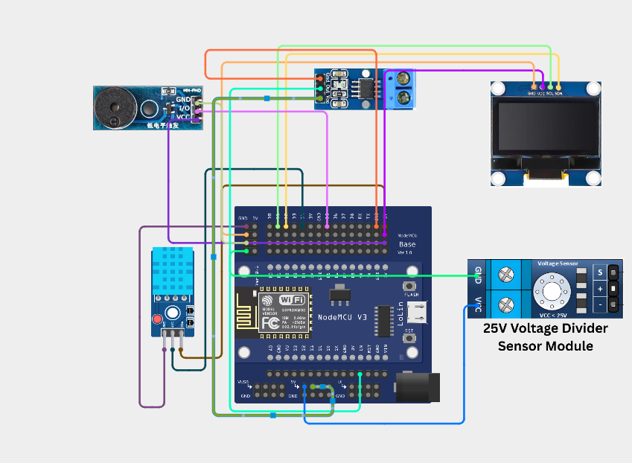

- Algorithm:
Step 1 Start the system.
Step 2 Initialize the ESP32 and connect to Wi-Fi.
Step 3 Initialize the voltage sensor, ACS712 current sensor, and DHT11 sensor.
Step 4 Configure the buzzer pin as an output.
Step 5 Read the voltage sensor value.
Step 6 Read the current sensor value.
Step 7 Read temperature and humidity from the DHT11.
Step 8 Compare the measured parameters with predefined threshold values.
Step 9 If abnormal voltage, over-current, or high temperature is detected, turn ON the buzzer.
Step 10 If all monitored parameters are within the normal range, turn OFF the buzzer.
Step 11 Display the readings and generator status on the Serial Monitor.
Step 12 Upload voltage, current, temperature, and humidity to ThingSpeak.
Step 13 Wait for the required upload interval.
Step 14 Repeat the monitoring process continuously.

- Coding:

#include <WiFi.h>
#include <HTTPClient.h>
#include <DHT.h>
#define BUZZER_PIN 25
#define CURRENT_PIN 35
#define DHT_PIN 4
#define VOLTAGE_PIN 34
#define DHT_TYPE DHT11
DHT dht(DHT_PIN, DHT_TYPE);
float ACS_SENSITIVITY = 0.100;
float VOLTAGE_FACTOR = 25.0;
float ADC_VOLTAGE = 3.3;
// In the original project, Wi-Fi credentials and
// ThingSpeak API key are configured here.
void setup() {
Serial.begin(115200);
pinMode(BUZZER_PIN, OUTPUT);
digitalWrite(BUZZER_PIN, LOW);
dht.begin();
analogReadResolution(12);
// Connect ESP32 to Wi-Fi and initialize
// ThingSpeak/cloud monitoring.
}
void loop() {
float temperature = dht.readTemperature();
float humidity = dht.readHumidity();
int currentRaw = analogRead(CURRENT_PIN);
float currentVoltage = (currentRaw / 4095.0) * ADC_VOLTAGE;
float current = (currentVoltage - 2.5) / ACS_SENSITIVITY;
if (current < 0) current = 0;
int voltageRaw = analogRead(VOLTAGE_PIN);
float sensorVoltage = (voltageRaw / 4095.0) * ADC_VOLTAGE;
float generatorVoltage = sensorVoltage * VOLTAGE_FACTOR;
bool alarm = false;
if (generatorVoltage < 100) {
Serial.println("OFF / LOW VOLTAGE");
} else if (generatorVoltage < 180) {
Serial.println("WARNING - LOW VOLTAGE");
} else if (generatorVoltage <= 250) {
Serial.println("NORMAL");
} else {
Serial.println("WARNING - HIGH VOLTAGE");
alarm = true;
}
if (!isnan(temperature) && temperature > 50) {
Serial.println("ALARM : HIGH TEMPERATURE");
alarm = true;
}
if (current > 20) {
Serial.println("ALARM : OVER CURRENT");
alarm = true;
}
digitalWrite(BUZZER_PIN, alarm ? HIGH : LOW);
// Upload voltage, current, temperature and humidity
// to ThingSpeak when Wi-Fi is connected.
delay(20000);
}

- System Working:
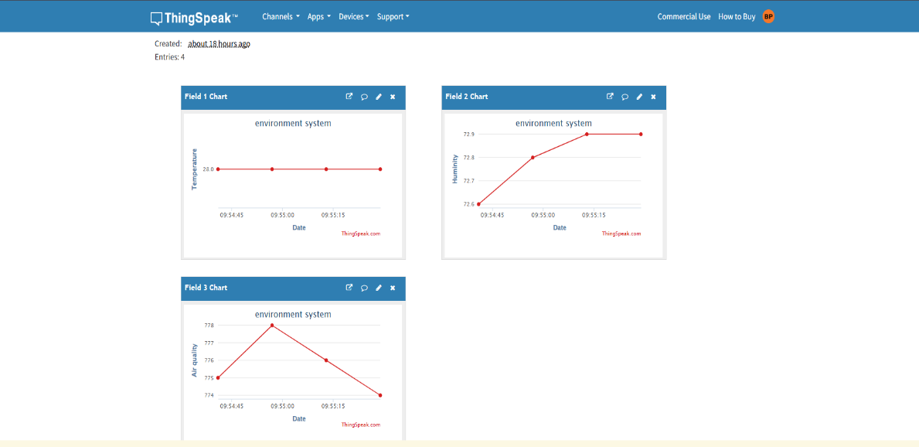

10. Working sequence:
Sensors → ESP32 → Data Processing → Threshold Comparison → Buzzer Alert → Serial Monitor → Wi-Fi → ThingSpeak Cloud → Preventive Maintenance

11. Bill of Materials:

S.No. | Component | Quantity
1 | ESP32 Development Board | 1
2 | Voltage Sensor Module | 1
3 | ACS712 Current Sensor | 1
4 | DHT11 Sensor | 1
5 | Buzzer | 1
6 | Breadboard | 1
7 | Jumper Wires | As required
8 | Regulated Power Supply | 1

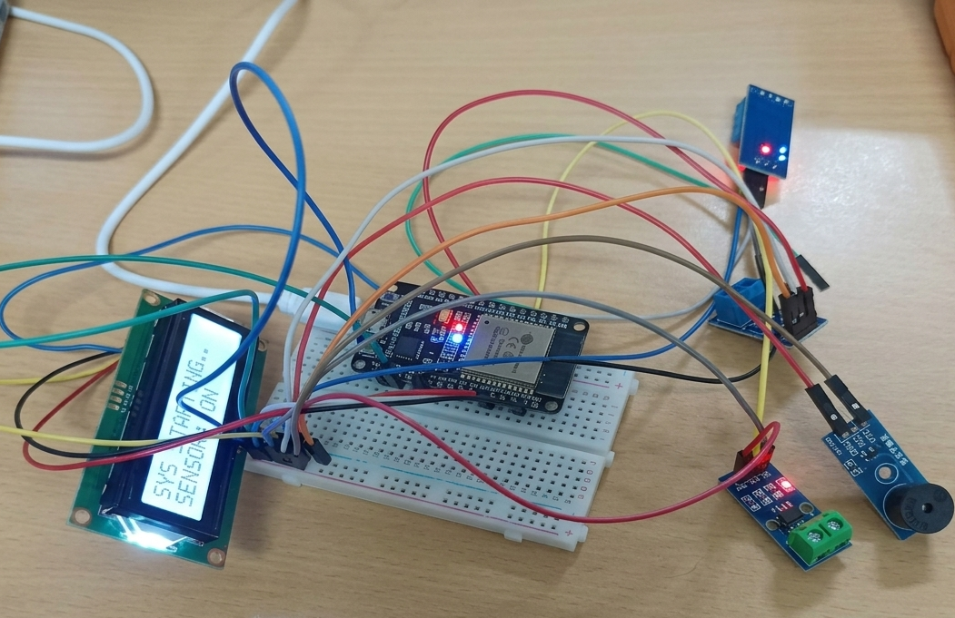
12. Prototype Implementation:

13. Results and Performance Analysis:

The system provides:
- Real-time generator monitoring.
- Early detection of abnormal operating conditions.
- Immediate local alerting through the buzzer.
- Remote monitoring and historical data logging through
ThingSpeak.
- Reduced dependency on manual inspection.
- Support for condition-based preventive maintenance.

Advantages:
- Continuous generator monitoring.
- Early fault detection.
- Instant buzzer alert.
- Reduces manual inspection.
- Remote ThingSpeak monitoring.
- Supports preventive maintenance.
- Low-cost IoT system.
- Easy future expansion

Limitations:
- Sensors require calibration.
- Depends on Wi-Fi connection.
- DHT11 measures ambient temperature.
- Cannot directly control the generator.
- Industrial sensors are needed for real use.
- ThingSpeak has update limitations.
- Thresholds must match generator ratings.

